[08343] “It’s a Hard Ants Life” Game Proposal
Word Count: 2152

Section A

Initial Concept Design

Objectives of Game

The player is an environmentalist who has been given the task of protecting a much endangered species of ant. This ant has been found to cure certain infections with the venom contained within it. Unfortunately, these ants live in a very hospitable environment which could mean the end of this rare species. The objective of the player is to guide and protect these ants through greater levels of danger by using items to guide them to safety, each level that the player completes means scientists get that one step closer to a cure.

Functionality

Progression through game

Each stage that the player successfully completes means the cure is developed further. The player will be shown a graphic which shows this cure slowly being made. This will also act as a way of showing the different levels to the player. Giving the player a tangible goal will encourage them to progress further into the game and ultimately lead them to finding a cure for the infection.

Visual Aspects of the game

The players will see a top-down view of the environment. The ants will start to walk in out of the initial nest after a short time. The player will be able to see items which they can drag onto certain areas of the map to move the ants towards particular directions (shown in Appendix D, figure 1 and 2). The player will be also able to remove any items they have placed on the map, but they will not be able to use them again. The items could be such things as:

Direction sticks – Will either move the ants left or right
Path-blocking rocks – Will block up entire paths and cause the ants to turn back around
Ant Attracting cakes – Will encourage the ants to turn a particular direction
“Bridge Builder” pheromone – Will encourage the ants to build a bridge over obstacles like water

When a player successfully guides the ants to safety, they will be given a score depending on a multitude of factors such as how many ants are left still alive etc (shown in Appendix D, figure 3). This score will be shown on screen at all times and will build up over progression through the levels.

Even though the overall goal of the game is serious, the soundtrack will consist of playful and light-hearted music. This is to work with the aesthetics of the game which will be in a cartoon style, being bright and colourful. A real-world comparison would be the visual style of the angry birds series, however there should not be any problems with violating its IPR or copyright as it’s not a copy of the visual style only similar.

Analysis of How the Game Meets the Clients Needs

The game has been primarily designed to highlight a particular career that can be chosen from biology. The game also encourages children to look further into biology careers as after every level is completed by showing snippets of information and facts about biology and future careers (shown in Appendix D, figure 3).

The specification also requires that it is suitable for 13-16 year olds, so it should have varying levels of difficulty. My game has a sloped difficulty curve, so it allows players of any age to play and progress though the game.

The game needs to take only a few minutes to play and as my game is a top-down puzzler this allows me to create levels which will fit the time restraints perfectly. There will also be a feature which allows the player to speed up time to complete levels quicker. This enables players to get through to harder levels faster and ultimately give the game replayability as they can progress further into the game each time without having to spend long amount of time on old levels.

Another requirement is that it can appeal to both genders. It will appeal to girls as they will like the characters contained in the swarm that they are trying to save (explained later). It will give them more impotence to play the game as they will want to see more characters in the swarm (which completing each level reveals). It will also appeal to boys as they would enjoy the challenge of completing each level, each level can also be completed in different ways also which again adds to the replayability value.

The client also requests that the game will be a windows application and that it can be easily downloaded over the internet, I have specifically designed the game to be easily created in XNA which can easily made to be downloadable. The client has also asked that the game could support any special needs. The game has been designed so that it does not need any sound to be playable; the gameplay is also very simple to understand so there is not very much text the user needs to read. This should accommodate any children who are hard of hearing or have sight problems.

Section B

Market Analysis and Business Plan

Equivalent Games already in Market

Searching through the game market, there are quite a few similar games that already exist. Harking from the retro market, the most famous game which spawned many similar titles would be Lemmings; this is where my game takes most of its influence from.

Even briefly searching the market for similar products brings a whole array of games such as:

Sandman – Direct sleeping “gnomes” to a certain goal by dropping sand to build slopes
Little Soldiers – Take direct control of a group of soldiers who use special abilities to reach a goal
The Lost Vikings – Take control of three Vikings and use their unique skills to reach a goal

Looking into the market I see there should be no threat with violating the IPR or copyright of other similar games. This is due to the game being influenced by them but different in gameplay, such as the player uses items to guide the ants, instead of directly affecting them like in games such as Lemmings.

Analysis of Game Market

The computer games market in 2010 was valued to around 2.1 billion (shown in Appendix C, figure 5); this is mainly due to new interest from technology advancements like the PS Move and Kinect. The same year the market has made a shift towards software sales rather than consoles with sales around 70% of the entire gaming market at around 1.3 billion (shown in Appendix C, figure 6).

Going further into detail, the edutainment sector has a relatively small share in the market and is not popular with consumers with only 4% choosing this as their favourite game genre. However, as my game could also be considered a puzzler this opens a much larger area of the market and is the most popular genre of game with consumers (shown in Appendix C, figure 7).

The UKs current population of 13-16 year olds is just under 3 million (data taken from UNESCO’s world statistics) with an overwhelming 96% of these playing computer games. With all this information gathered I would say that the potential market for my game would be around 3.5 million pounds (shown in Appendix E, figure 2).

Possible Methods of Maximising Revenue

Franchising

The visual design could branch out to include characters in the ant swarm. These characters could then be developed to be products in their own rights specifically collectable figurines, an example of this is Gogo’s Crazy Bones which sold around 23 million figurines in the UK. The UK toys market is estimated to grow to steadily till 2013 when it will be worth around 2.2 million (as shown in Appendix C, figure 1) and specifically the collectable figurines market is worth around 130 million (as shown in Appendix C, figure 2).

Internet site

With a limited budget developing an internet site would be an excellent way to promote and sell products to a wider market. Even though internet sales only account for around 7-8% of the market value, the growth is very promising with a 40% increase sales through the internet from 2005 to 2007 (shown in Appendix C, figure 3). Another option would be to sell through an already well-known internet company, as they could sell and promote the product more effectively. Selling the game and products to either Amazon or Play.com who together share an overwhelming 65% of the market sales for game software (shown in Appendix C, figure 4) could be a wise move.

Diversifying the product

The project brief states that the game only needs to be playable on the PC. This however could be extended to include other platforms such as mobile phones. A staggering 94% of kids aged 11-15 own a mobile phone and 65% of these play games on them (stated in Edutainment - UK - March 2009 report).

Ethical Aspects

To avoid ethical issues the infection that the ant’s venom cures is unspecified. This is to avoid claiming something that does not really exist. This would be especially bad if a player has someone they know which has that infection, giving them false hope that there is a cure here and now. Also the designers must be careful with stereotyping when creating the individual characters in the swarm, so they will create very generic characters like a “rocker” ant or a “princess” ant.

Development Schedule and Project Management Plan

Development Schedule

Development Costing

This will be based on a team of around 6 people working 37 hours a week over a 6 week period. The wage will be around £10 an hour (shown in Appendix E, figure 3). The office space costs are equivalent to a location in Hull which costs from around £500 a month; this includes costs of utilities. The extra calculations are for tools such as Visual studio (£1400 for two copies) and Microsoft office (costing £429). If other avenues of revenue were implemented then this would be the additional costs of that (shown in Appendix E, figure 4).

Potential Profit

From the research I have done I have broken down the games market into relevant figures (shown in Appendix E, figure 2).

Using these figures I will aim to achieve 2% sales of the whole market in the first year, the next year the product will sell 5% of the market as the customer base become more aware of the game through websites and a £10,000 advertising campaign. This would again increase another 5% to 10% for the third year as the game is developed for the phone market and the £20,000 franchising campaign is implemented.

Year | Sales | Outgoings | Profit/Loss
1 | £69,888 | £15,899 | £53,989
2 | £174,720 | £27,099 | £147,621
3 | £349,440 | £32,779 | £316,661

These final figures do seem a bit speculative and should be taken with a pinch of salt, but the sales achieved from each of the years even when trying to achieve 2% percent of the market are encouraging.

Roles and responsibilities of development team

The roles of the team would be as follows if the team is based on five people:

Role 1 Planning\Managing (1 members) – I see this person as the team leader; they will be involved in all stages of the project and will guide the rest of the team. Responsibilities would be:

- Manage entire project from start to finish, this means contacting\supporting team members, keeping SharePoint up to date, meeting minutes, arranging meetings etc
- Planning of the structure of the program, this means the team member will sit alongside the programmers and develop class diagrams etc. The rest of the team will also be present but it’s the responsibility of this team member to officially write up the documents

Role 2 Visual Design\Marketing (2 members) – These members will work with the whole team to get a general overall consensus of how the game will look and feel. Their responsibilities are:

- Research about the market and give meaningful conclusions about how the game should look visually and develop these aspects into an overall visual style
- Supply the implementation team with any/all artwork that they may need
- Create marketing plans and strategies which will promote the product effectively

Role 3 Implementation (2 members) –Their responsibilities would be:

- Plan and implement the game following the class diagrams developed by the planning
- Write up weekly work reports to show overall progress
- When overall program is completed, to work closely with the testers (if available) to both show them how the system works but also to fix bugs that are found

Additional role 4 Testing (1 member) – Responsibilities will be:

- Playing through the game, use black box testing initially then white box testing to try and find any bugs. These bugs will then be put into an official report for the programmers to fix

Appendix A – Project Time Plan
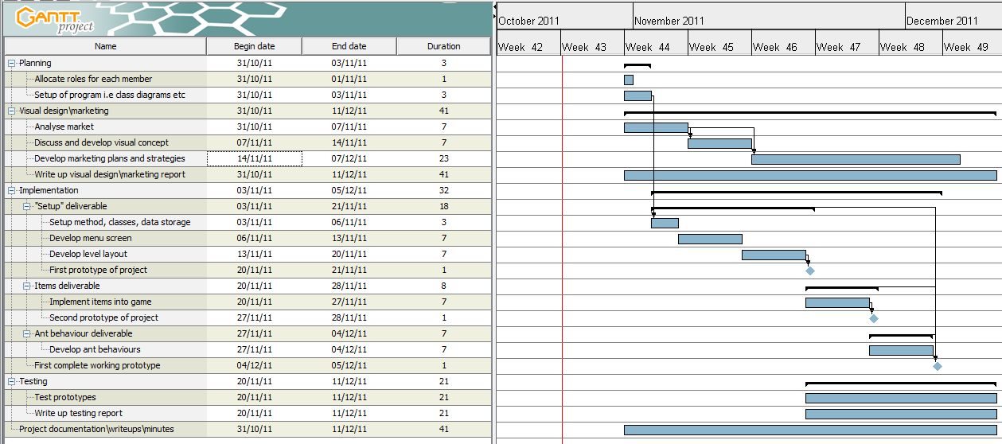

Appendix B – Pert Chart

Figure 1: This is a pert chart of my time plan; the boxes highlighted in red are the critical path of the project

Appendix C - Market Research

Taken from Toys and Games - UK - November 2008 report
Source: Mintel

Taken from Toys and Games - UK - November 2008 report
Source: Mintel

Taken from Toys and Games - UK - November 2008 report
Source: Mintel

Taken from Computer and Video Game Retailing - UK - September 2006 report
Source: GMI/Mintel

Taken from Video Games and Consoles - UK - October 2010 report
Source: Mintel

Taken from Video Games and Consoles - UK - October 2010 report
Source: Mintel

Taken from Video and Computer Games - UK - August 2008 report
Source: GMI/Mintel

Taken from Computer and Video Game Retailing - UK - September 2006 report
Source: GMI/Mintel

Appendix D - Concept Art
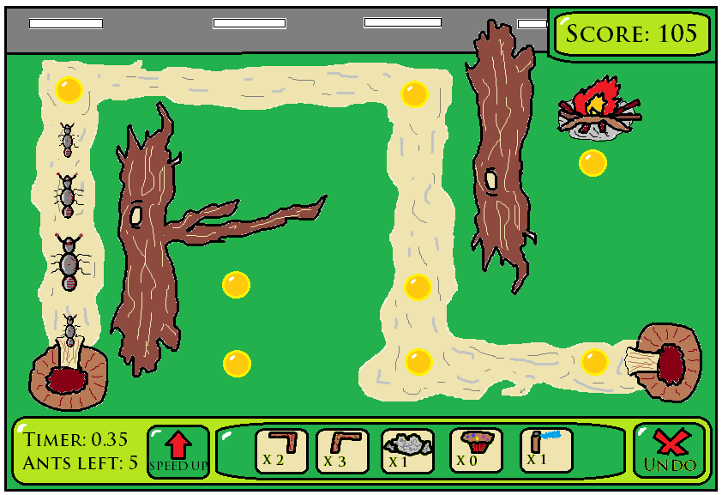

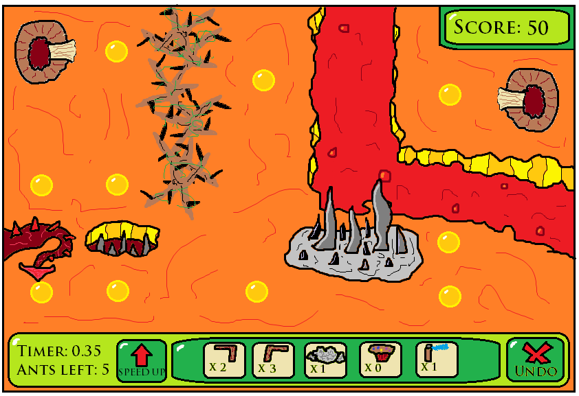
Figure 1: Concept art of main game screen, yellow orbs indicate where items can be placed, example of an easy level as path is shown to the player

Figure 2: Concept art of another level that could be developed, this level is slightly harder and there is no path for the player to follow this time
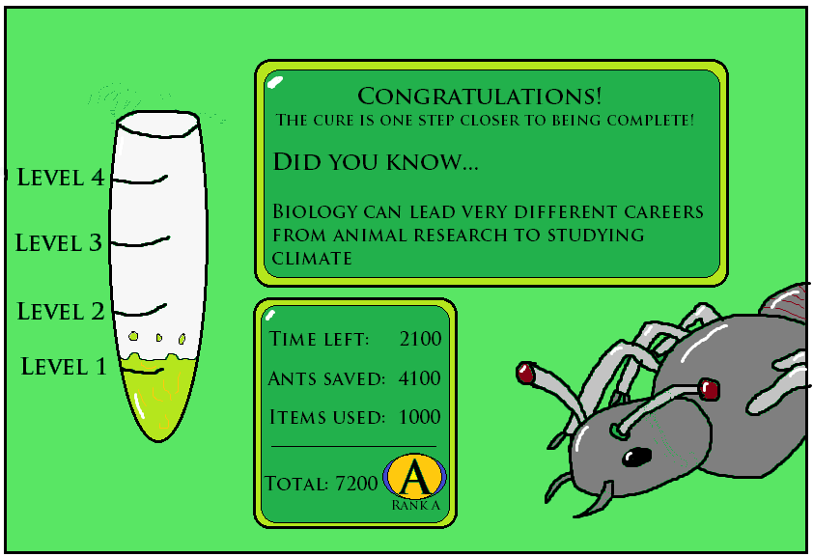

Figure 3: Concept art of the level screen, here the scoring of the last level will also occur and facts will be displayed about biology to the player

Appendix E – Development Costs
Job\Role | Total hours worked | Cost
Artists (1 member) | (37 * 6) * 1 = 222 | 222 * 10 = £2220
Programmers (2 member) | (37 * 6) * 2 = 444 | 444 * 10 = £4440
Testers (1 member) | (37 * 6) * 1 = 222 | 222 * 10 = £2220
Marketer (1 member) | (37 * 6) * 1 = 222 | 222 * 10 = £2220
Manager (1 member) | (37 * 6) * 1 = 222 | 222 * 10 = £2220
Fixed Costs e.g. rent, support, tools etc | Not applicable | (500 * 1.5) + (700 * 2) + 429 = £2579
Total | 1332 | £15899
Figure 1: Shows internal development costs of the project

Description of demographic | Amount
Software sector | £1.3 billion
Edutainment sector has 5% of this market | £65,000,000
Puzzle sector takes has 23% of the market | £299,000,000
Total demographic to aim for | £364,000,000
Total UK population | 61,838,154
Total population between 13-16 (5% of the UK) | 3 million
Target market is 5% of the total sector | 5% of 364 million is £18,200,000
Factor in that 96% of those 13-16 year olds play computer games | £17,472,000 or 2,968,230 consumers
Take into account average price of computer game | £25
Price of my game is £5 so divide the market by 5 to get the real potential market of my game | £17,472,000 / 5 = £3,494,400
Figure 2: Shows market calculations and potential market size

Avenues of revenue | Cost
Website implemented | £1000 plus £200 a year maintenance and support
Outsourcing to established companies | 30% of product sales
Diversifying the product | Xbox360 game around £30k and £300k. Mobile phone game £5k –£20k
Franchising | From £995 up to £100k depending on budget
Figure 3: Shows additional costs if other avenues of revenue were implemented

Bibliography

Mintel. 2010, Computer Software - UK - November 2010 [Online], Availible: http://academic.mintel.com/sinatra/oxygen_academic/search_results/show&/display/id=480942 [Accessed 15th Oct 2011]
Mintel. 2006, Computer and Video Game Retailing - UK - September 2006 [Online], Availible: http://academic.mintel.com/sinatra/oxygen_academic/search_results/show&/display/id=173672
[Accessed 14th Oct 2011]
Mintel. 2009, Edutainment – UK – March 2009 [Online], Available: http://academic.mintel.com/sinatra/oxygen_academic/search_results/show&/display/id=395146
[Accessed 15th Oct 2011]
Mintel. 2008, Toys and Games - UK - November 2008 [Online], Available: http://academic.mintel.com/sinatra/oxygen_academic/search_results/show&/display/id=280200 [Accessed 17th Oct 2011]
Mintel. 2008, Video and Computer Games - UK - August 2008 [Online], Available: http://academic.mintel.com/sinatra/oxygen_academic/search_results/show&/display/id=280418 [Accessed 16th Oct 2011]
Mintel. 2010, Video games and Consoles – UK – October 2010 [Online], Available: http://academic.mintel.com/sinatra/oxygen_academic/search_results/show&/display/id=479875 [Accessed 16th Oct 2011]
Encyclopaedia of the Nations. 2011, Population, aged 13-16, total - Population - Education Statistics [Online], Available: http://www.nationsencyclopedia.com/WorldStats/Edu-population-13-16.html [Accessed 18th Oct 2011]

James Batchelor. 2011, Average price of a video game: £24.32 [Online], Available: http://www.mcvuk.com/news/read/average-price-of-a-video-game-24-32/04088 [Accessed 20th Oct 2011]

